Name | Yedoti Premchand
Roll Number | 23BTRCT074
HCL ID | HCLTFP2260962
College Name | JAIN University
Batch | 2027
Date | 28/10/2026
Title | HCLTECH – CLOUD & DATA ENGINEERING ASSESSMENT 2

SECTION A: ADVANCED SQL

Question 1: Database Design and Advanced Queries

Created a database named EnterpriseDB
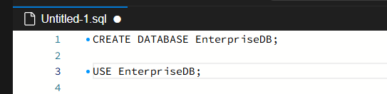

Created the tables Employees and Departments
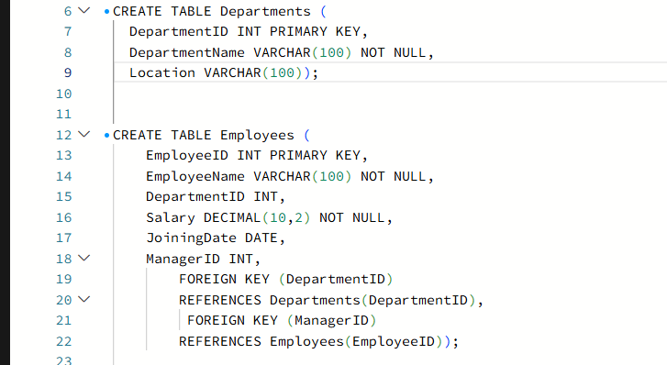

Inserted employee records and department record
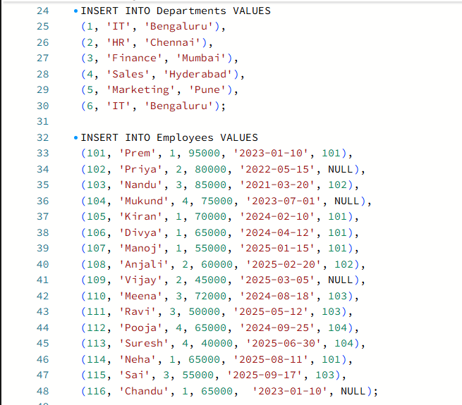

Display employee names, department names, and manager names using joins.
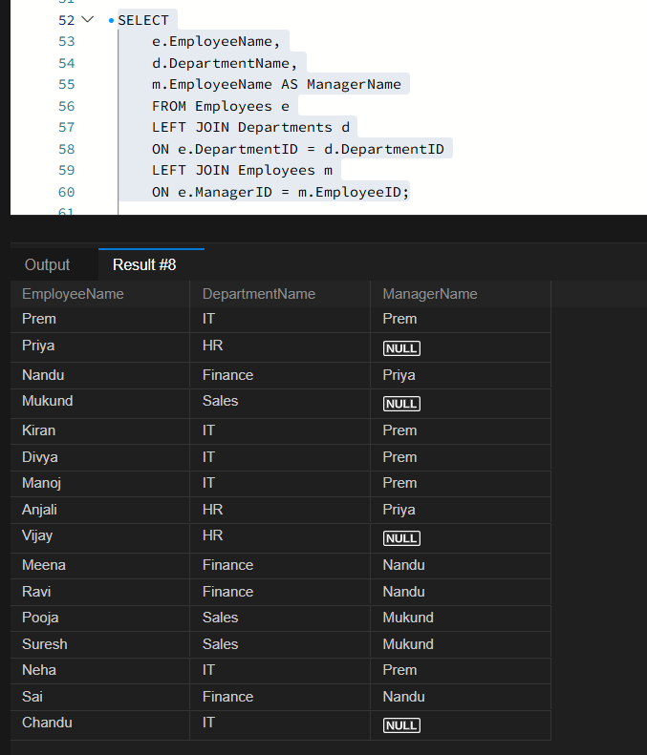

Employees earning more than their department's average salary

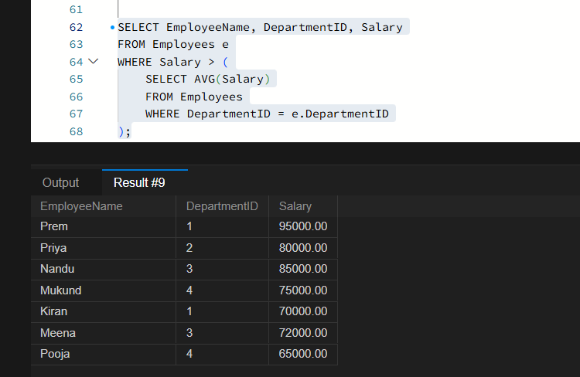

The second-highest distinct salary without using LIMIT, TOP, or FETCH FIRST.

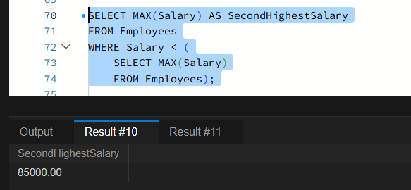

Rank employees by salary within each department and display the top three employees per department, retaining ties at the cutoff

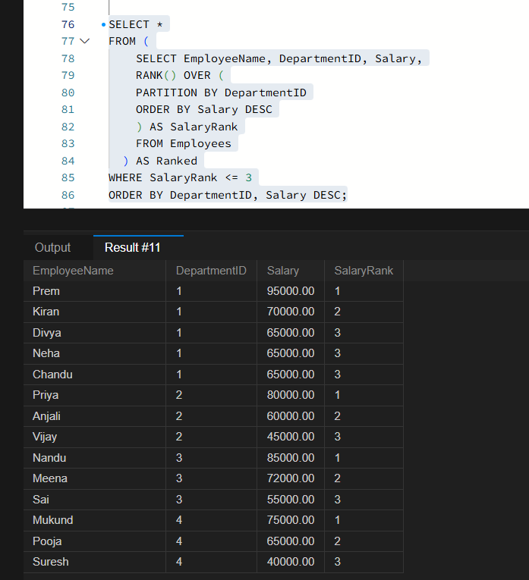

Question 2: Sales Analytics and Query Optimization

Created a Sales table
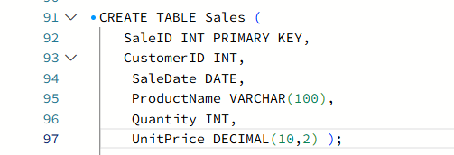

Inserted Sales Records
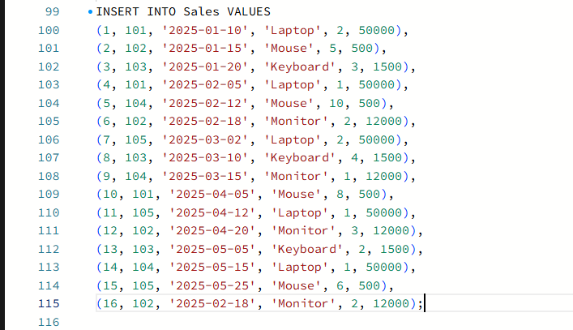

Total revenue for each product
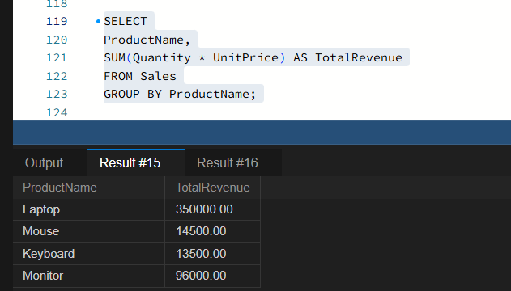

Monthly revenue and month-over-month revenue
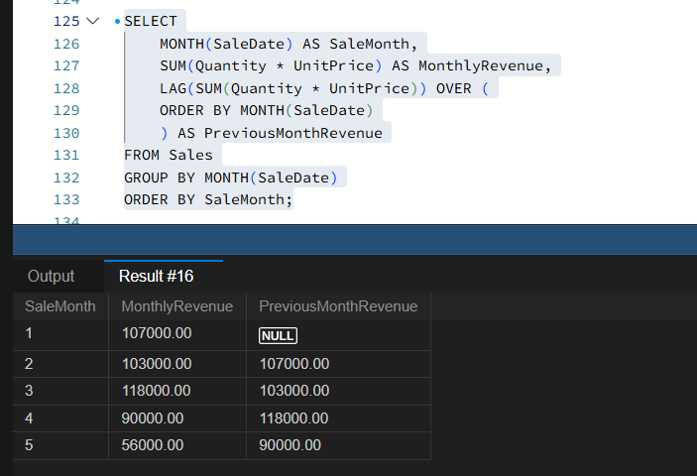

To improve the potential for index usage
SELECT * FROM Employees WHERE YEAR(JoiningDate) = 2025;
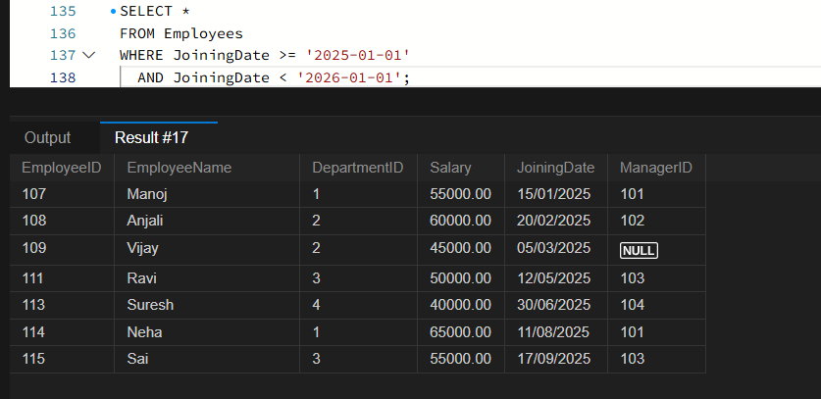
- This query retrieves employees who joined in 2025.
- It avoids applying the YEAR() function to JoiningDate.
- If an index exists on JoiningDate, the database can potentially use it to find records faster.

Question 3: SQL Troubleshooting

execution plan helps identify expensive operations in a query.
An execution plan shows how SQL runs a query. It helps us find what is making the query slow, such as reading the entire table or performing costly operations.
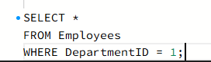

an appropriate index strategy for queries filtering employees by DepartmentID and Salary.
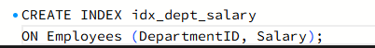

This index helps the database to find the employees by department and salary faster, especially when the table contains millions of records.

query to identify duplicate customer email addresses and display only addresses occurring more than once.
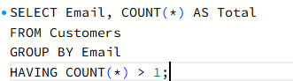

SECTION B: LINUX
Question 4: Log Analysis

To find all lines containing ERROR
-- grep "ERROR" /var/log/application.log
By using the key word “ grep ” we can display the all lines

To display the 20 most recent error entries
grep "ERROR" /var/log/application.log | tail -n 20

Count the total number of error entries
grep -c "ERROR" /var/log/application.log
-c counts the lines containing the ERROR

Extract error entries for a specified date into a separate file
grep "2026-10-28 ERROR" /var/log/application.log > errors_2026-10-28.log
Finds the error entries for the specified date and saves them into errors_2026-10-28.log

Calculate the number of errors occurring in each hour.
grep "ERROR" selects error lines, sort groups matching hours together, and uniq -c counts errors for each hour.
Question 5: Permissions and System Troubleshooting
Created a group named finance and the report file
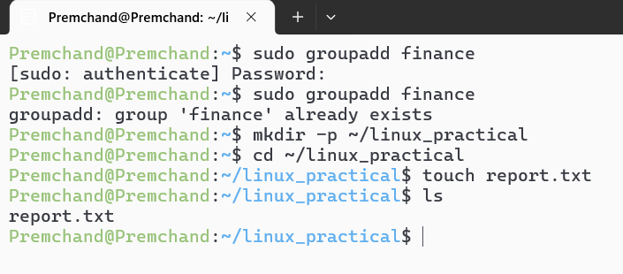
Set permissions
We need these permissions:
Owner: read and write
Finance group: read only
Other users: no access

To identify the processes consuming the most CPU
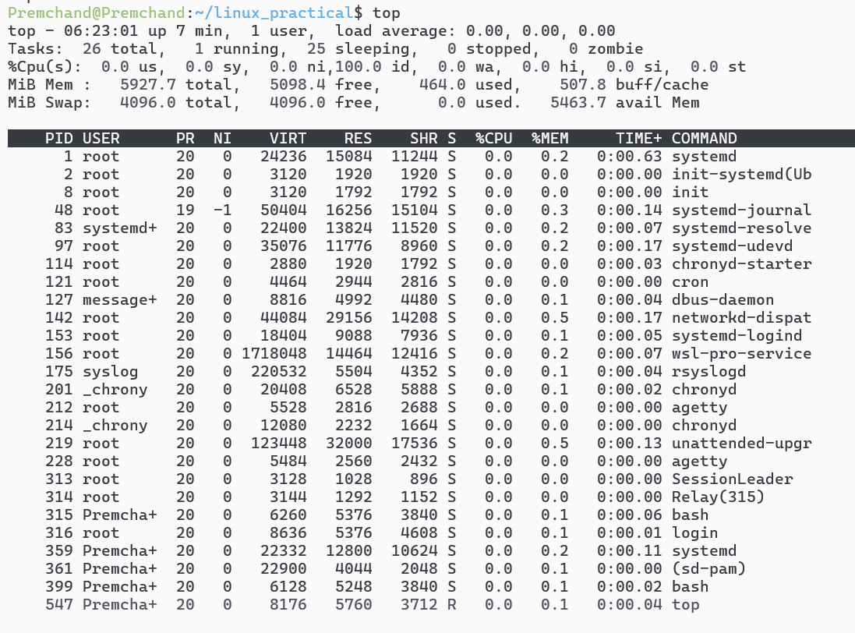
By using “TOP” we can displays running processes and the CPU usage.
To display memory usage and filesystem disk utilization
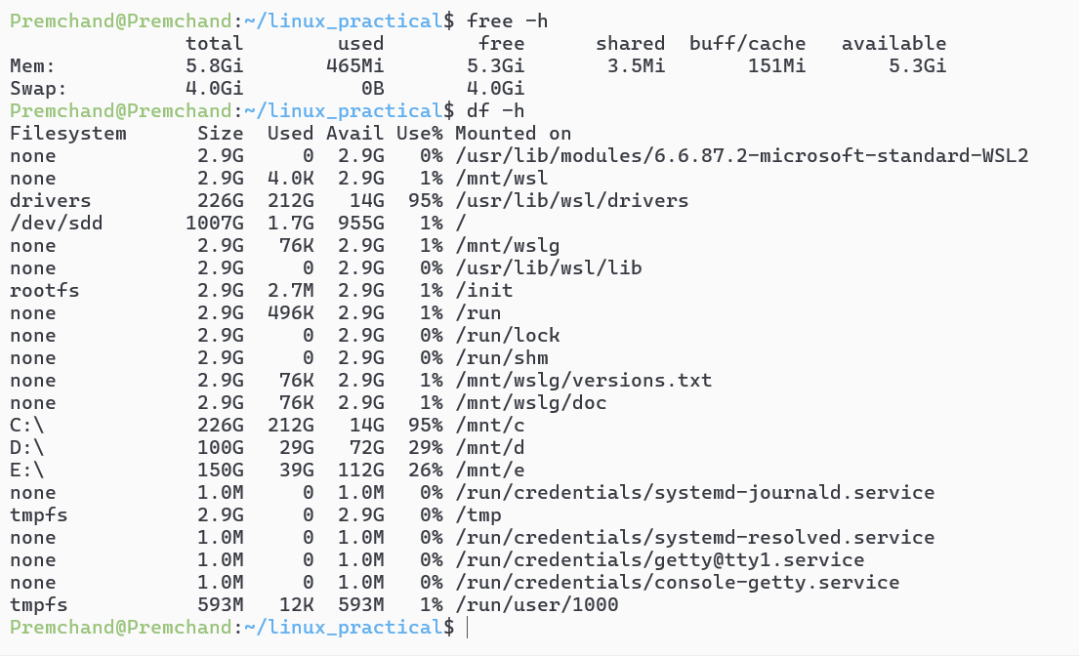
Question 6: Bash Scripting
Bash script named backup_check.sh
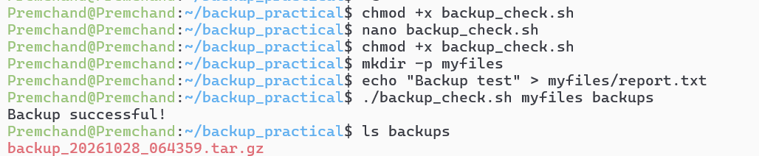
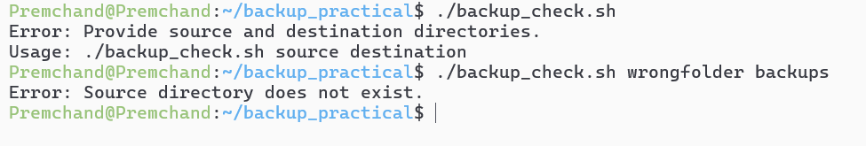
SECTION C: PYSPARK DATA ENGINEERING
Question 7: PySpark DataFrame Operations
Created the PySpark DataFrame and Inserted the records
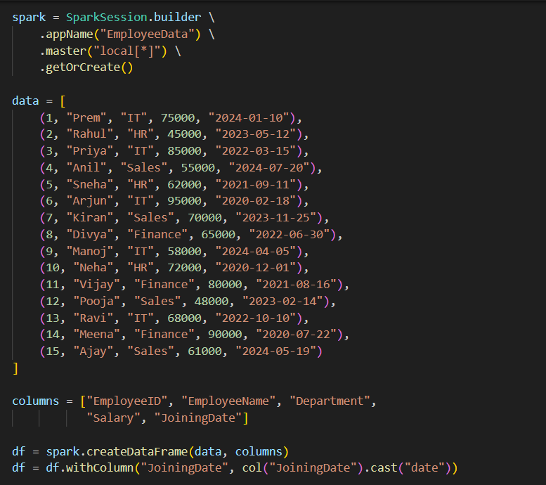
To display the schema and first five records
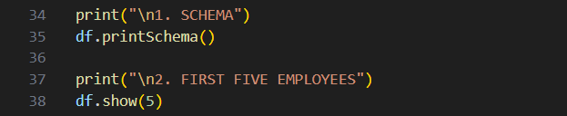
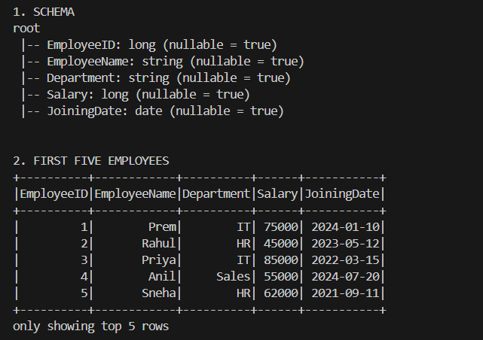
Filter employees whose monthly salary is greater than ₹60,000
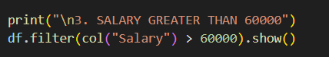
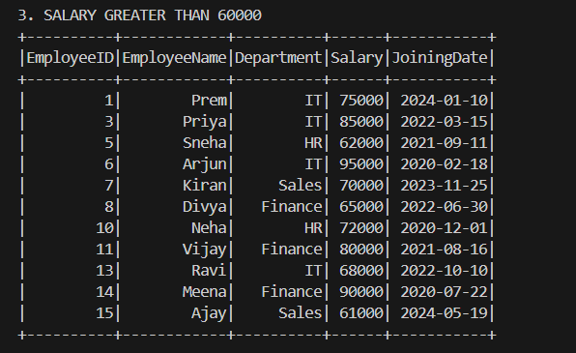

Added an AnnualSalary column calculated from the monthly salary
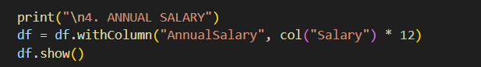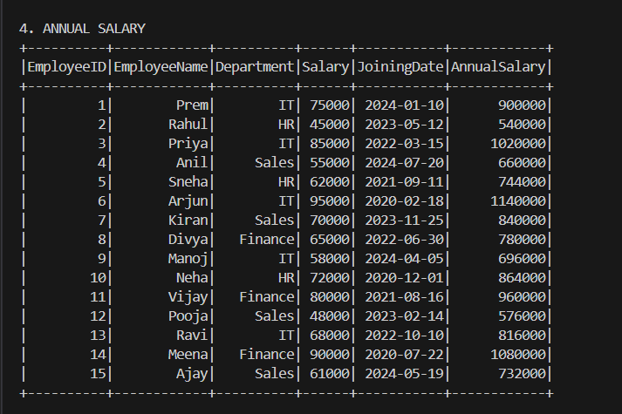
Group employees by department and calculate the average salary and employee count
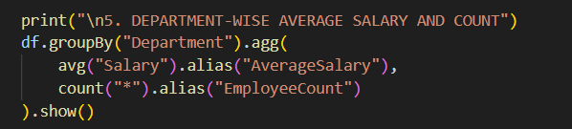
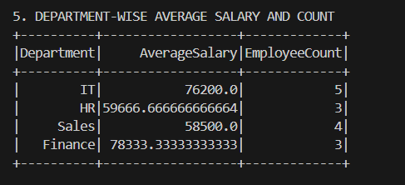

To display the five highest-paid employees
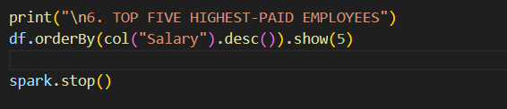
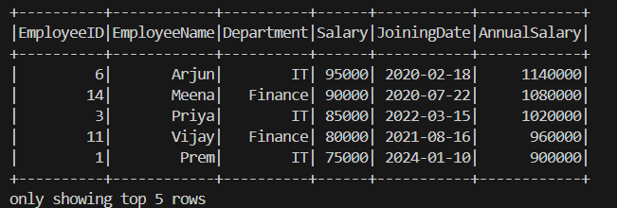
Question 8: Data Cleaning and Aggregation
Read the CSV file using an appropriate schema and header configuration.
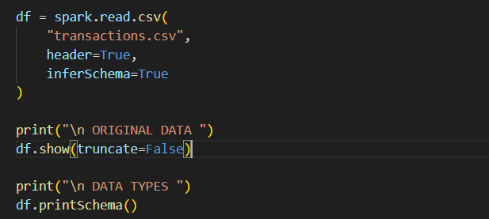
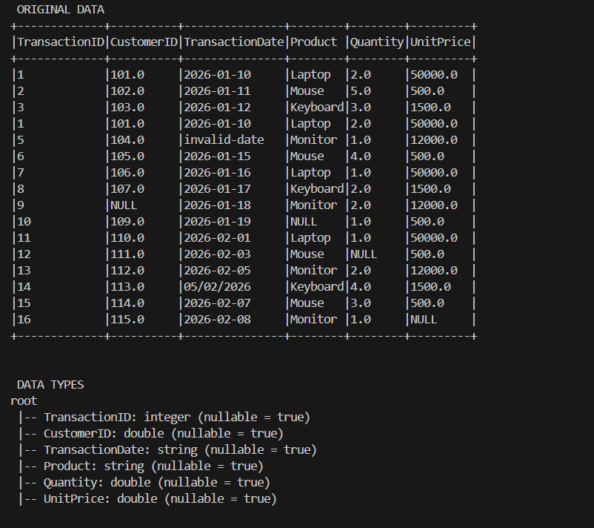
To identify and remove duplicate transactions
and Handle missing values in required fields
and Convert TransactionDate into a date type and handle invalid dates
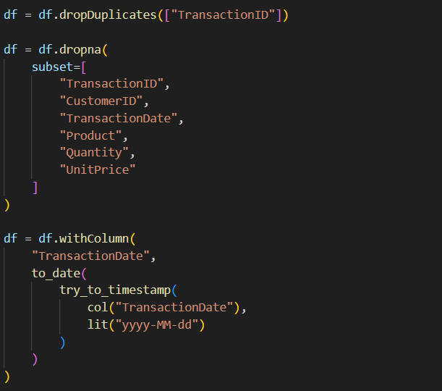
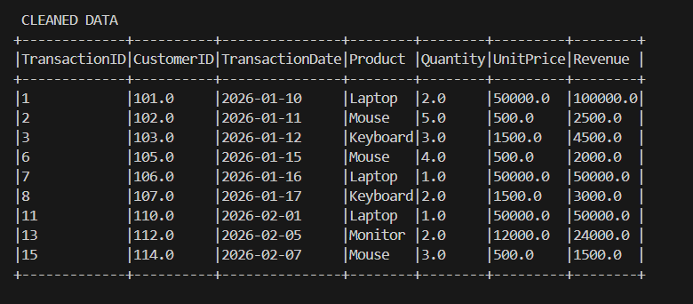

Calculate revenue using Quantity × UnitPrice.
And Calculate total revenue by product and display the results in descending order
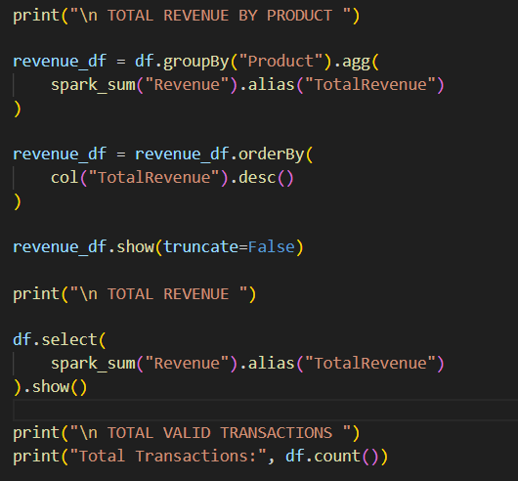
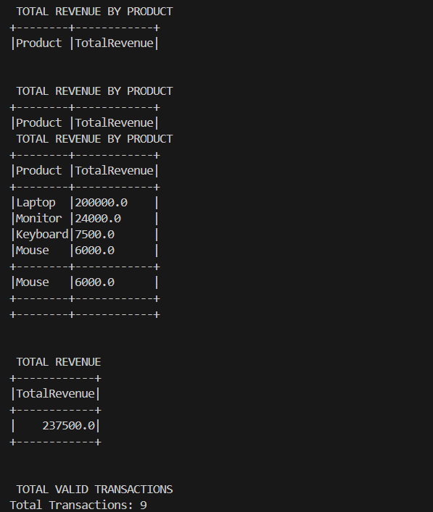
Question 9: PySpark Joins and Performance
Loaded both datasets into DataFrames
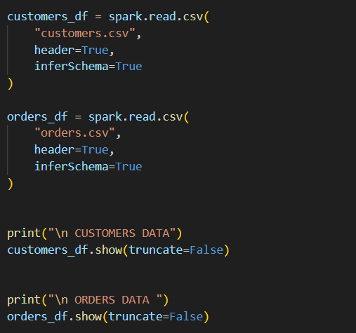
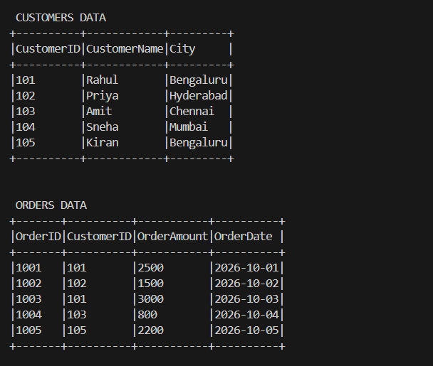

Join the datasets to display orders with customer details
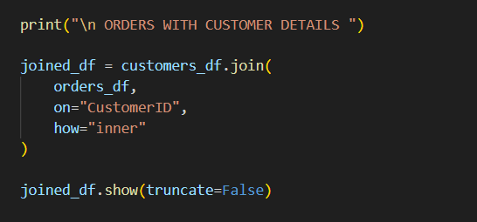
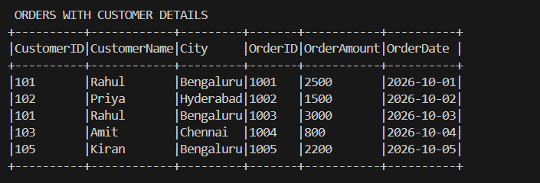
Identify customers who have never placed an order.
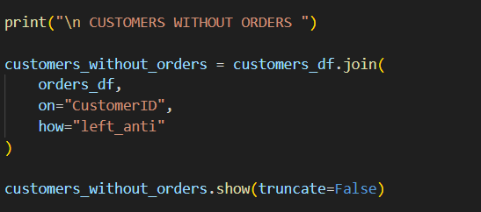
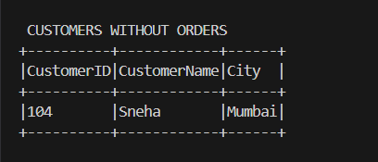

Calculate the total order value by city
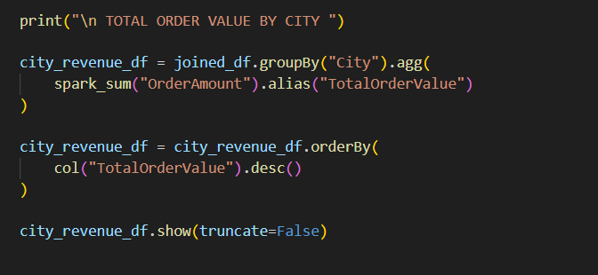
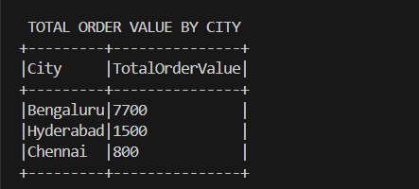
broadcast join is useful and what conditions make it appropriate
A broadcast join is useful when one DataFrame is small enough to fit in the memory of each worker node. Spark sends a copy of the smaller DataFrame to the workers, which can avoid shuffling the larger DataFrame and improve join performance.
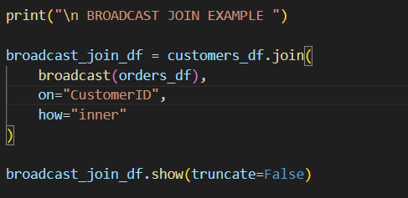
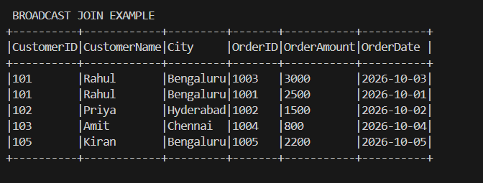
the difference between transformations and actions
Transformation: Creates a new DataFrame or describes a computation.
Examples: filter(), select(), join(), groupBy().
Action: Triggers execution and returns or displays a result.
Examples: show(), count(), collect().

SECTION D: AWS CLOUD SERVICES
Question 10: S3 and IAM Security
Created an S3 bucket with Block Public Access enabled and uploaded a sample file
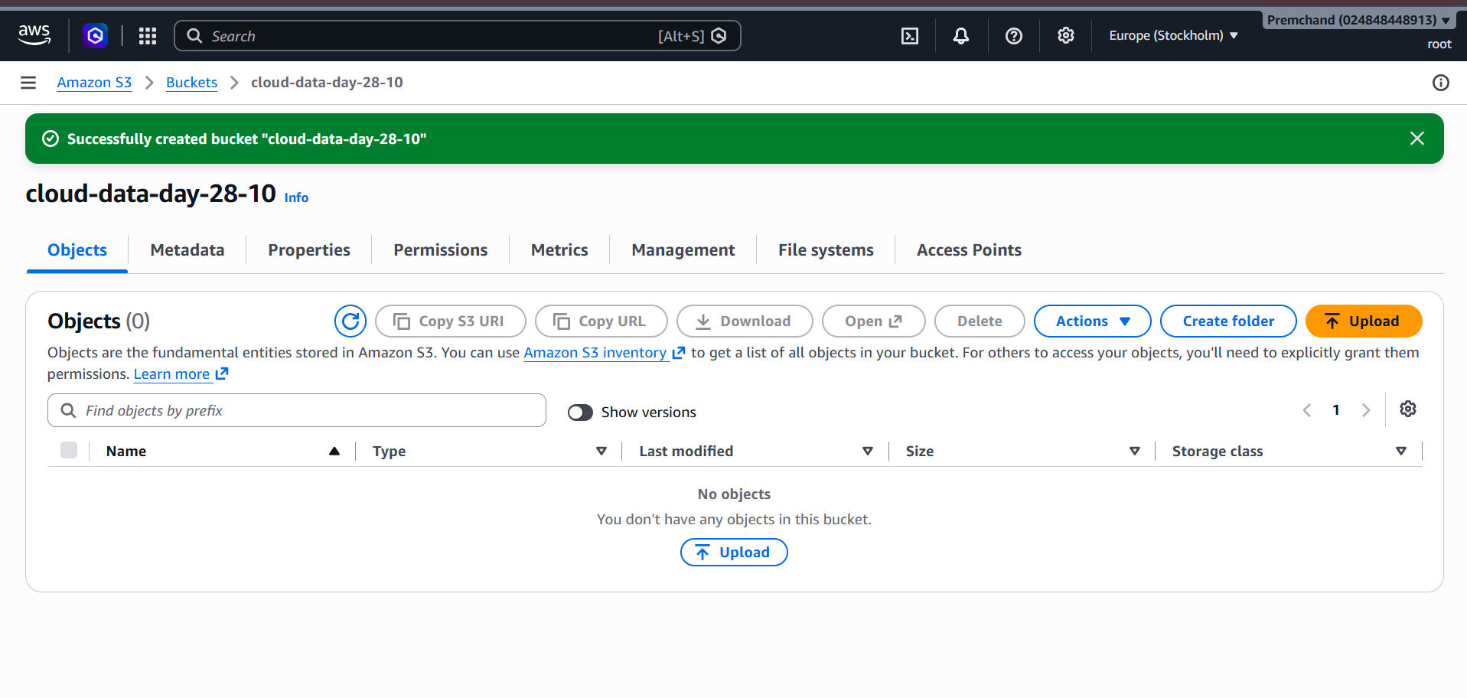
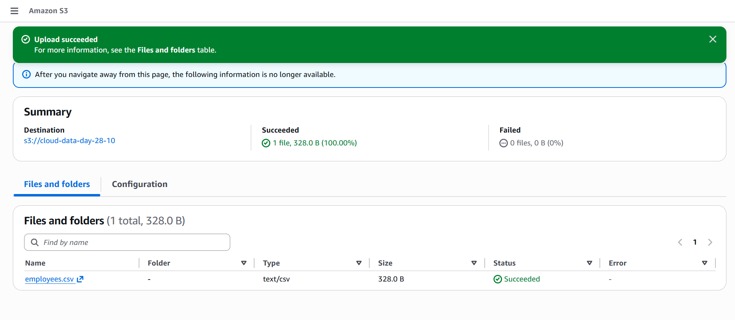
Design an IAM policy that grants read access to objects in the designated bucket without granting access to unrelated buckets.
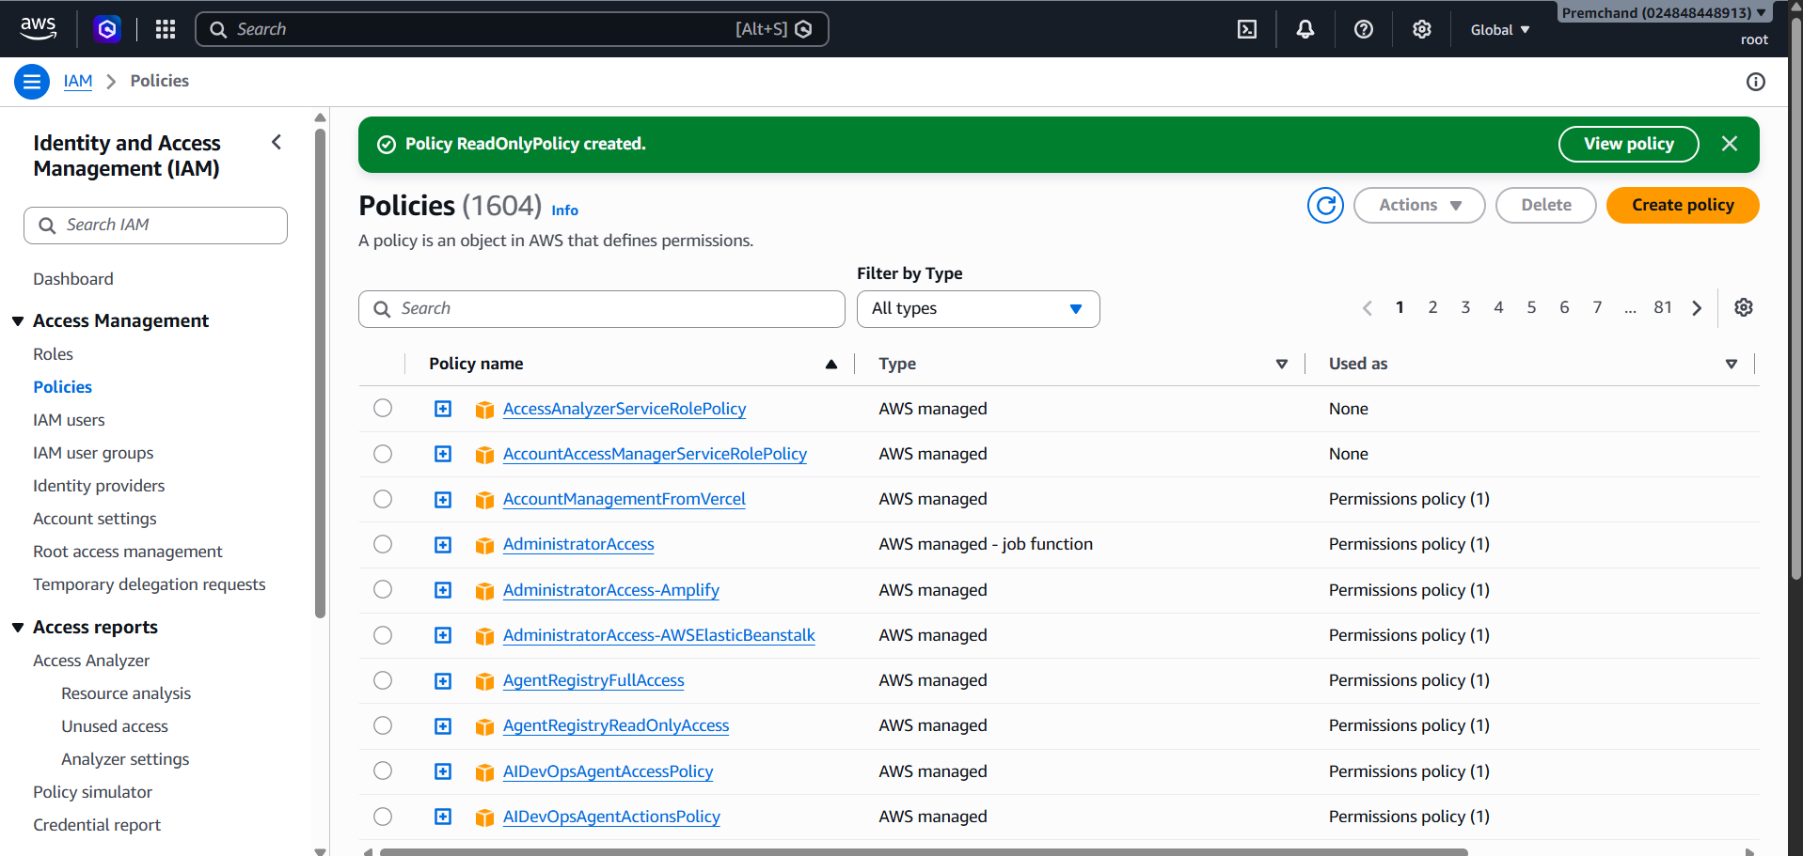
how you would verify that an unauthorized user cannot read the file
I would log in using an IAM user who does not have permission to access the S3 bucket and try to open or download the file. AWS should show an Access Denied message. Then, I would check that an authorized HR user can access the file successfully.
how encryption at rest protects the stored data
Encryption at rest protects files stored in Amazon S3 by converting the data into an unreadable format. Only authorized access can decrypt and read the data. This helps keep confidential employee reports safe even if someone gets access to the stored data without the required permissions.
Question 11: EC2 Troubleshooting and CloudWatch
Check the EC2 instance state and status checks
I would open the AWS Console and go to EC2 → Instances. I would check whether the instance is running and whether the system and instance status checks have passed. If any check fails, I would investigate the problem and fix it.

How security groups and route tables affect connectivity
Security groups act like firewalls and control incoming and outgoing traffic. If the required port, such as 80 for HTTP or 443 for HTTPS, is blocked, users may not be able to access the application. Route tables control where network traffic goes. If the routes are incorrect or missing, the application may not be reachable over the internet or through the required network.

Configure a CloudWatch alarm when CPU utilization exceeds 85%
I would follow these steps:
- Open AWS CloudWatch -> Alarms -> Create alarm.
- Select the EC2 instance's CPUUtilization metric.
- Choose Average as the statistic and set the period to 5 minutes.
- Set the alarm condition to CPU utilization greater than 85%.
- Set the evaluation period, for example, 3 consecutive periods of 5 minutes each.
- Configure an Amazon SNS notification to alert the administrator.
- Give the alarm a name, such as High-CPU-Alarm, and create it.

Question 12: Event-Driven Processing

Service for processing code
I would use AWS Lambda to run the code that checks and processes CSV files automatically without managing a server.

How an S3 upload triggers processing
When a CSV file is uploaded to an S3 bucket, an S3 event automatically triggers the Lambda function to process the file.

IAM permissions required
The Lambda function needs permission to:
Read files from the input S3 bucket using s3:GetObject
Write processed results to the output S3 bucket using s3:PutObject
These permissions should be given only for the required buckets.

How to capture errors and logs
I would use Amazon CloudWatch Logs to record the processing details and errors. This helps me find and fix problems. I can also set up email notifications for failures.

How to prevent duplicate processing or repeated triggering
I would track processed files to avoid processing the same file multiple times. I would also save the results in a separate output bucket so that uploading the results does not trigger the Lambda function again.

SECTION E: AWS STEP FUNCTIONS

Question 13: State Machine Design
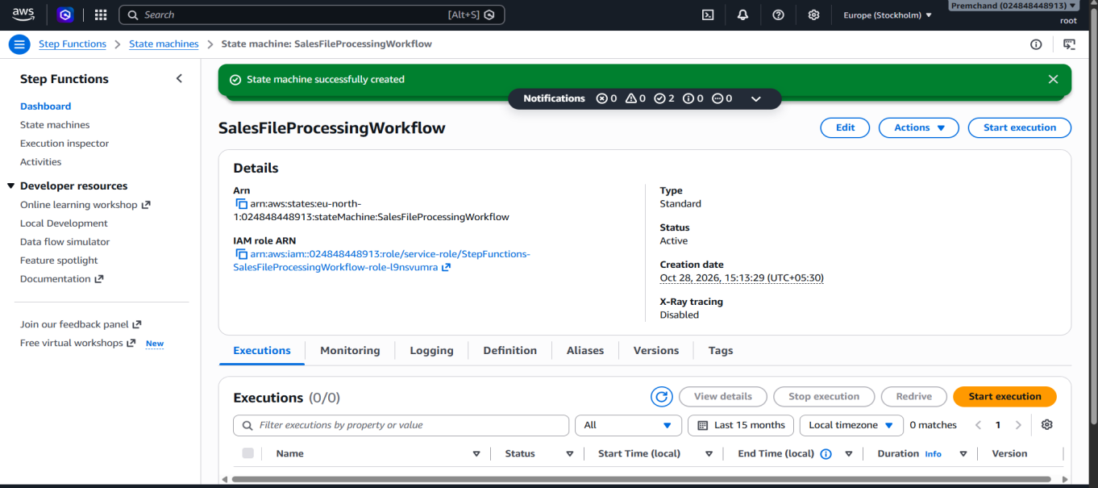
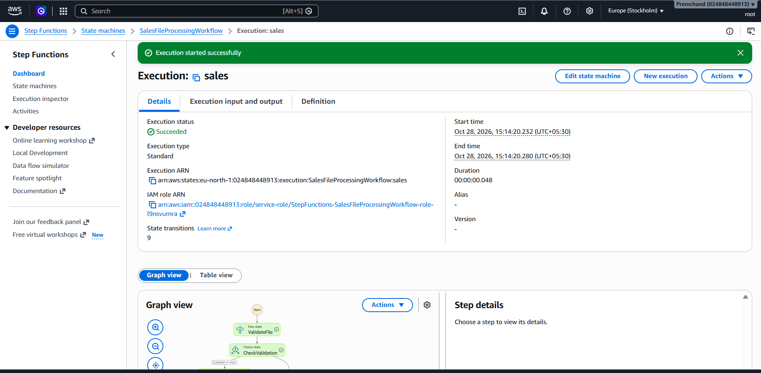
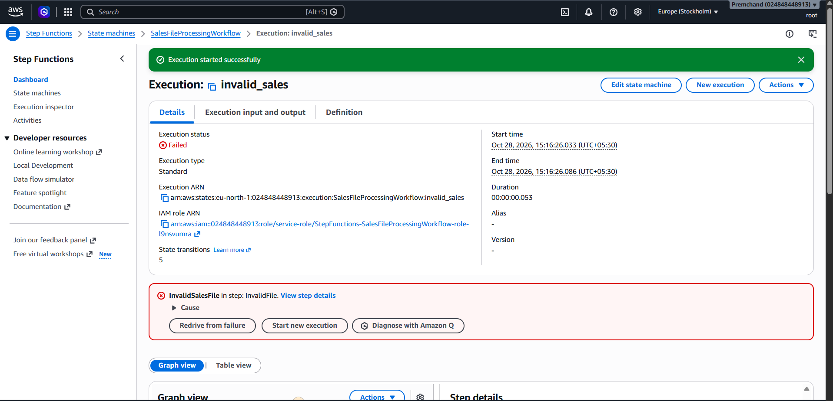
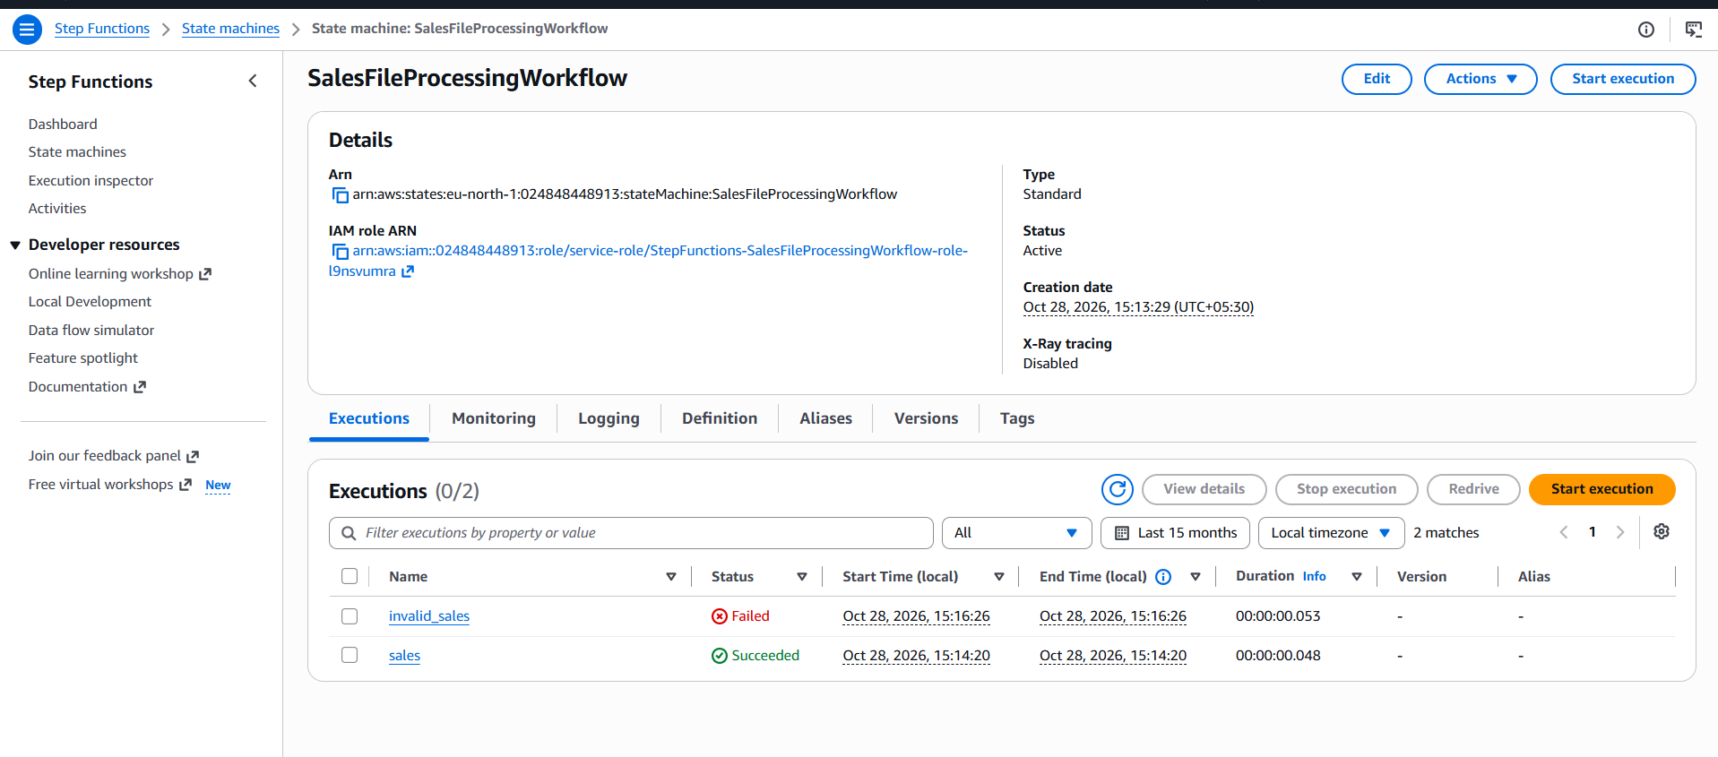
Identify suitable states for validation, processing, storage, and notification
The workflow uses Validate File, Transform Data, Calculate Sales, Store Results in S3, and Send Notification states to process the sales file step by step.
Explain how a Choice state can route invalid files to a failure path and valid files to processing
The Choice state checks whether the input file is valid. If valid, processing continues. If invalid, the workflow stops with a failure state.
Explain how Retry and Catch can handle transient failures and permanent errors
Retry tries an operation again when temporary errors occur. Catch handles errors that cannot be resolved and directs the workflow to a failure state.
Explain how the state machine can invoke Lambda functions or other supported AWS services
AWS Lambda performs validation and data processing, Amazon S3 stores the results, and Amazon SNS sends completion notifications.
Explain how execution history helps troubleshoot a failed workflow
Execution history shows each steps status, input, output, and error details. It helps administrators identify and fix workflow failures.
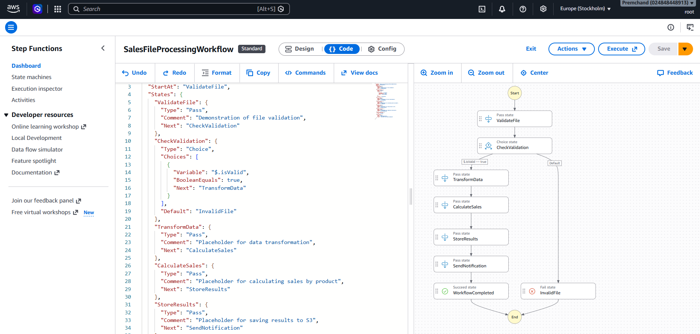

Question 14: Step Functions Implementation
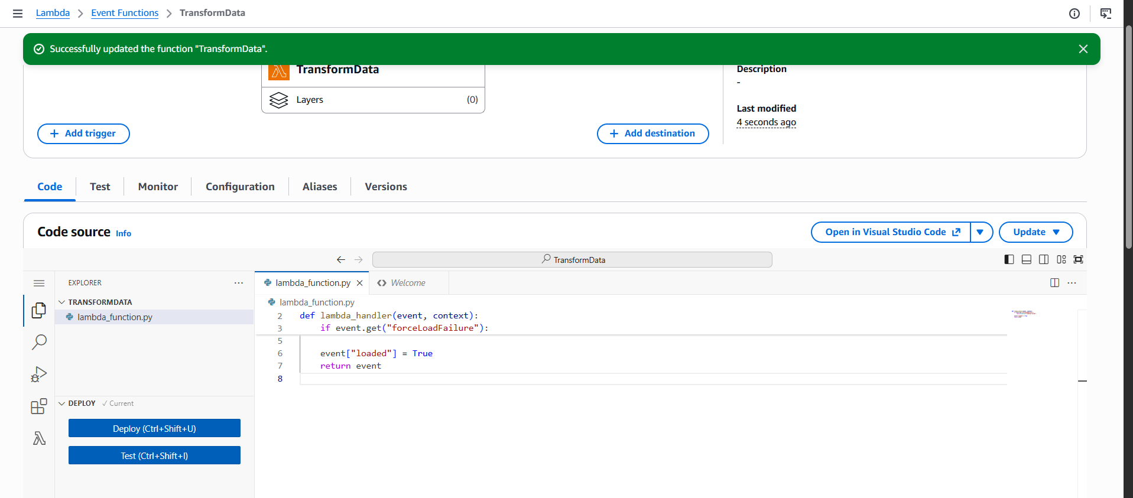
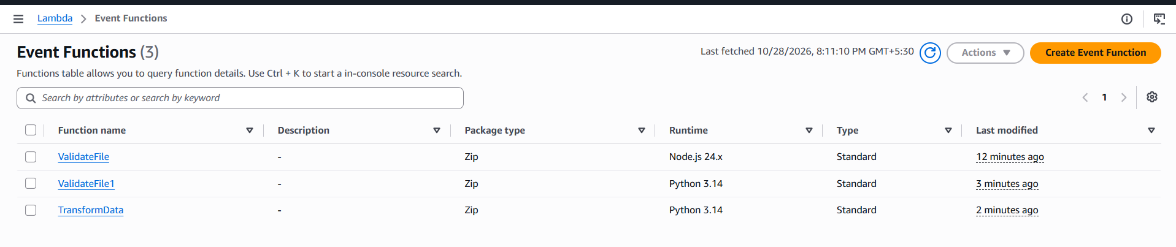
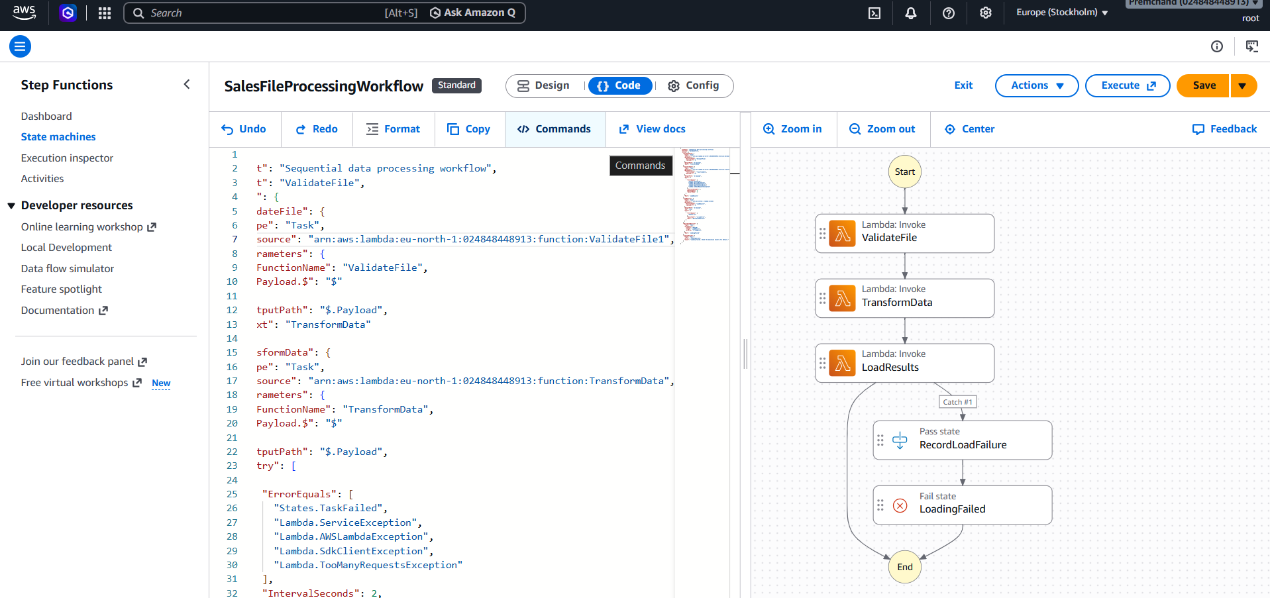
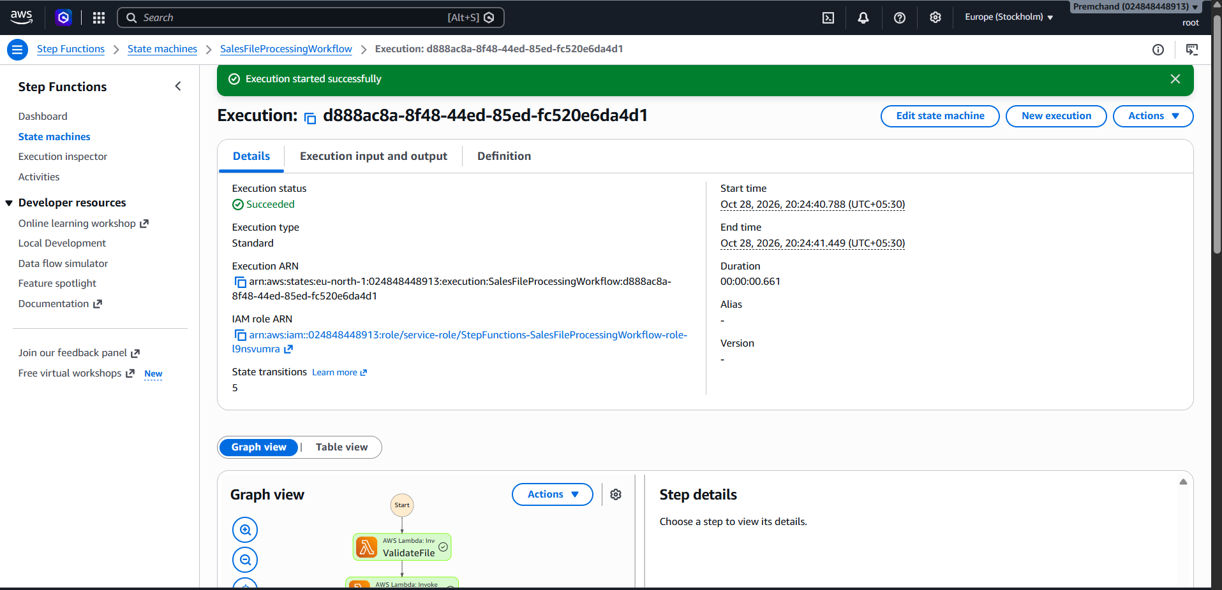
a. ASL JSON Definition
The workflow uses three tasks: ValidateFile, TransformData, and LoadResults. They execute one after another to process the data.
b.Retry Policy
If TransformData fails due to a temporary error, the workflow tries again up to 3 times, starting with a 2-second wait. This helps recover from temporary problems.
c. Catch Transition
If LoadResults fails, the Catch block sends the workflow to RecordFailure, which records the error.
d. Data Passing
The output of each task is passed as input to the next task, allowing the data to move through the workflow.
e. Testing
Test the workflow with valid input and check that all tasks succeed. Then test failures in validation, transformation, and loading. Check the Step Functions execution history to see errors, retries, and task status.

SECTION F: MICROSOFT AZURE
Question 15: Azure Data Lake Storage and Security
Configure or describe a storage account with hierarchical namespace enabled for Azure Data Lake Storage Gen2
Created a Azure Storage Account and enable Hierarchical Namespace to use Azure Data Lake Storage Gen2
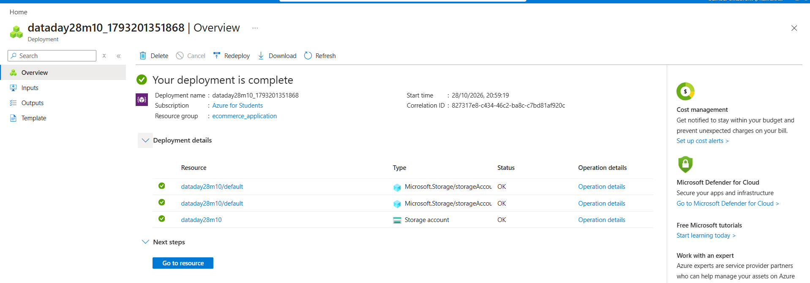
Create a filesystem or container and upload a sample dataset
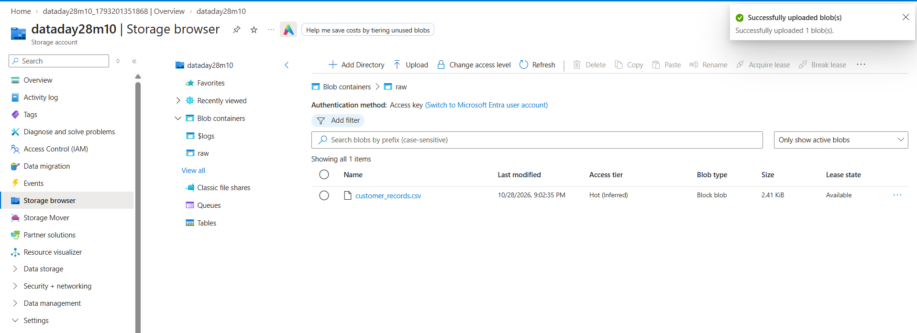
how Microsoft Entra ID and Azure role-based access control can manage access to the data
Microsoft Entra ID manages user login and identity. Azure RBAC gives permissions based on user roles. For example, an analyst can read data, while a data engineer can upload and modify files
Explain how you would verify that unauthorized users cannot access the dataset.
Log in with an unauthorized user and try to open the file. If access is denied, the security settings are working correctly.

Question 16: Azure VM Troubleshooting
Verify the VM's provisioning and power states.
Open the Azure Portal and check the VM's provisioning state is Succeeded and power state is Running.
Explain how Network Security Group rules can prevent connectivity.
NSG rules control network traffic. If the required port, such as SSH (22) or RDP (3389), is blocked, administrators cannot connect.
Explain how subnet and routing configuration affect connectivity.
Incorrect subnet settings or route tables can prevent network traffic from reaching the VM. Check the virtual network and routing configuration.
Recommend a secure troubleshooting method that avoids unnecessarily exposing the VM to the public internet.
Use Azure Bastion to connect to the VM securely through the Azure Portal. Check network settings and allow only trusted connections. Avoid exposing SSH or RDP ports to the entire public internet.
Question 17: Azure Data Integration
Select an appropriate service to orchestrate data movement.
We can use Azure Data Factory (ADF) to move data from one location to another and manage the data processing steps automatically.
Explain how to copy the CSV file into Azure Data Lake Storage Gen2.
Create a pipeline in Azure Data Factory and use the Copy Data activity to copy the customer transaction CSV file into Azure Data Lake Storage Gen2.
Describe how to organize files by ingestion date.
Store files in separate folders based on the date they are received.
example, create folders for year, month, and day. this makes it easy to find and analyze daily transaction data.
Explain how to handle malformed records and missing values.
Check the CSV file for missing values, incorrect formats, and duplicate records. Correct the data wherever possible and move invalid records into a separate error folder for checking.
Explain how to monitor pipeline execution and validate data completeness.
Use the Monitor section in Azure Data Factory to check whether the pipeline completed successfully. Compare the number of records in the original file with the copied file to make sure all data was transferred correctly.

